**Session: Introduction to Python**

**Name: Ahan Jain**

**EmpID: 8202**

**1. Given string my_string = ‘Hello Python!’, Reverse the string using slicing, print ’!’ using indexing.**

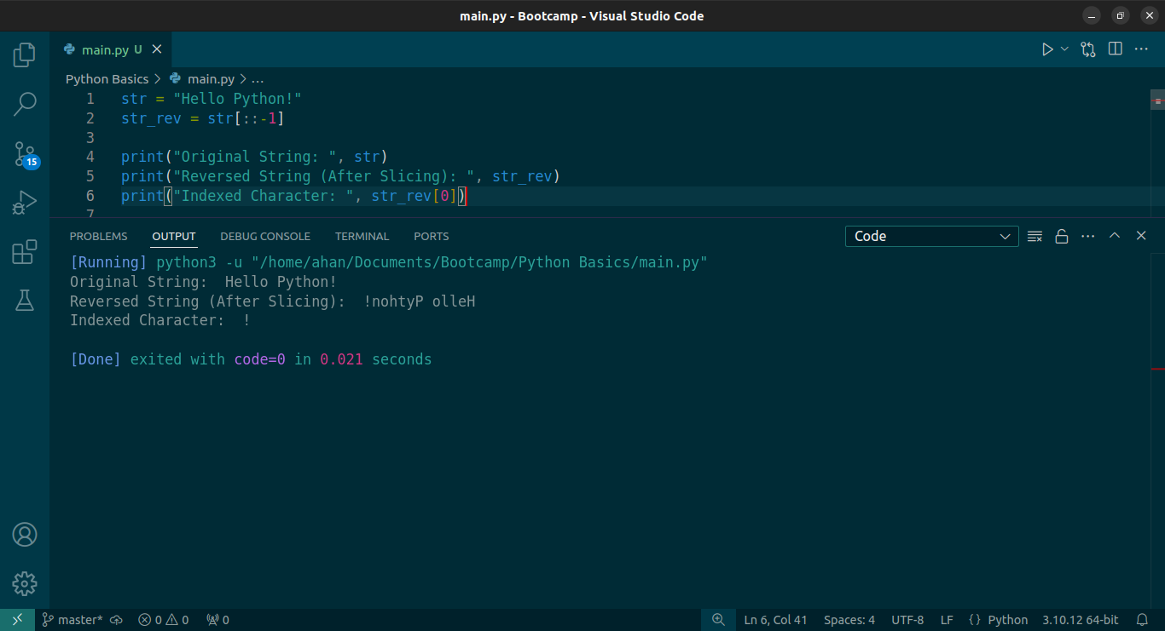

**2. Use slicing to get the word “frain” from “information”.**

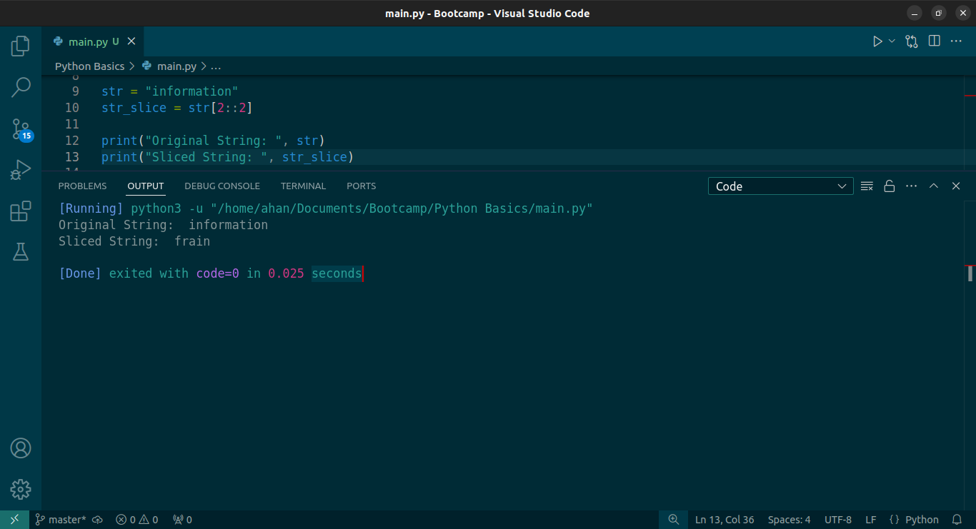

**3. Using examples explain string.format and f-strings**

Both string.format and f-strings are used for formatting strings in python.

The .format() method allows inserting variables into a string using {} placeholders.

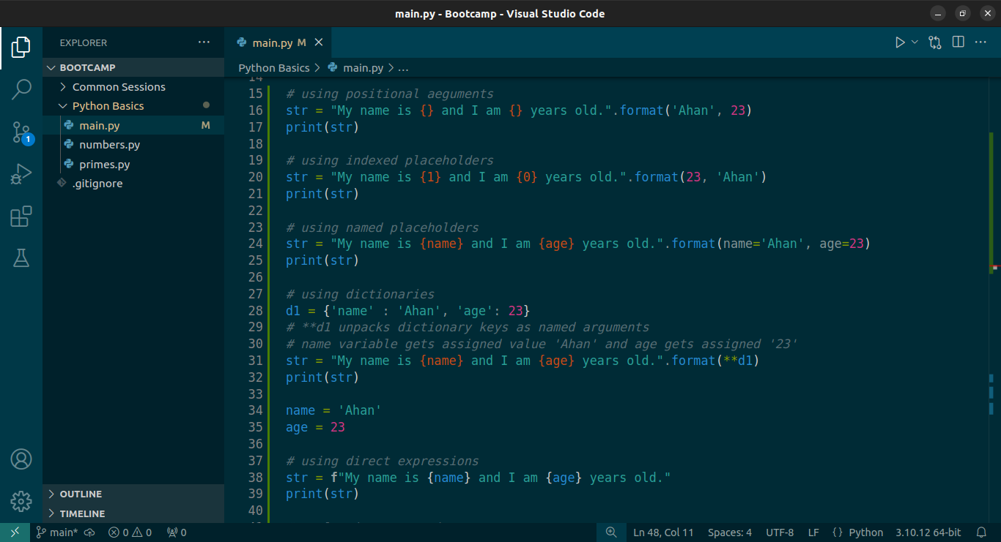

f-strings are a modern, concise, and efficient way to format strings.

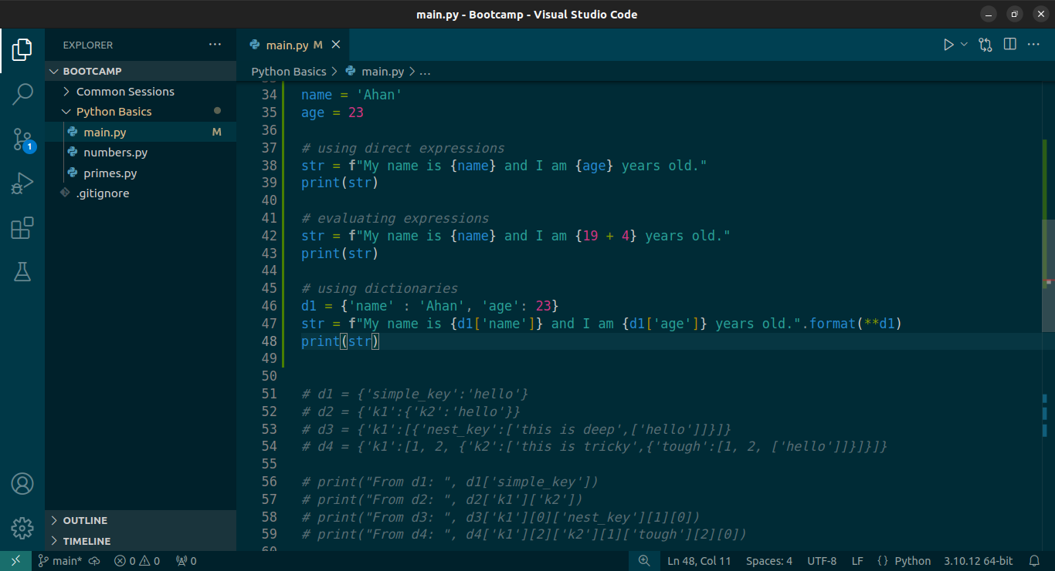

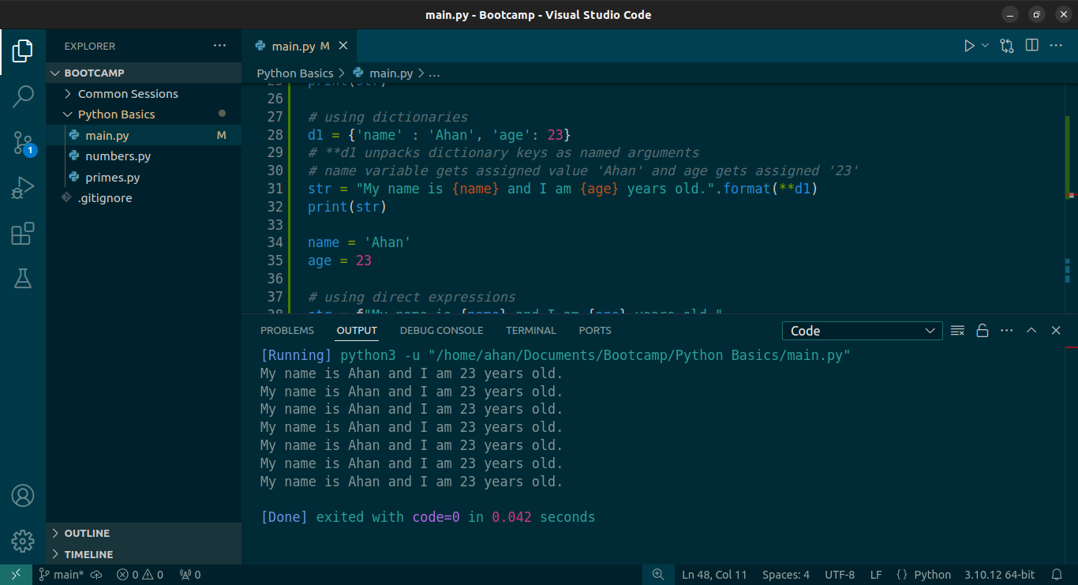

f-strings in Python are faster than .format() because they are evaluated at runtime without requiring function calls. This means that f-strings are directly processed by Python’s compiler, while .format() involves calling a method (str.format()) and performing multiple internal operations.

**4. Can we sort a dictionary? Why or why not?**

Method 1: Sorting by keys.

dict.items() returns a list of tuples which are passed to the sorted function. The sorted function sorts this list of tuples based on the first item i.e. the key. This is then explicitly converted into a dictionary.

Method 2: Sorting by values.

Since by default, sorted function sorts the list of tuples by first value i.e. the key, to sort using values we pass a function (a lambda function in this case) to specify we need the sorting to be with respect to the second value of the tuple i.e. the value.

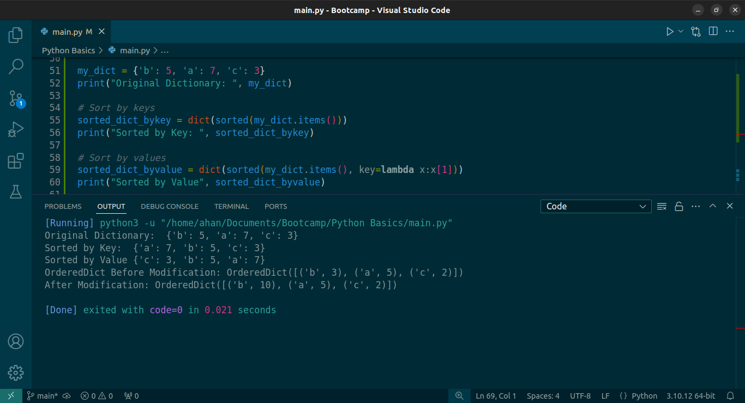

Method 3: Using OrderedDict to preserve key insertion order.

By default, order of insertion of keys is not maintained. This order also gets changed if a value is modified. To preserve the order of both insertion and prevent change of order during modification, OrderedDict can be used.

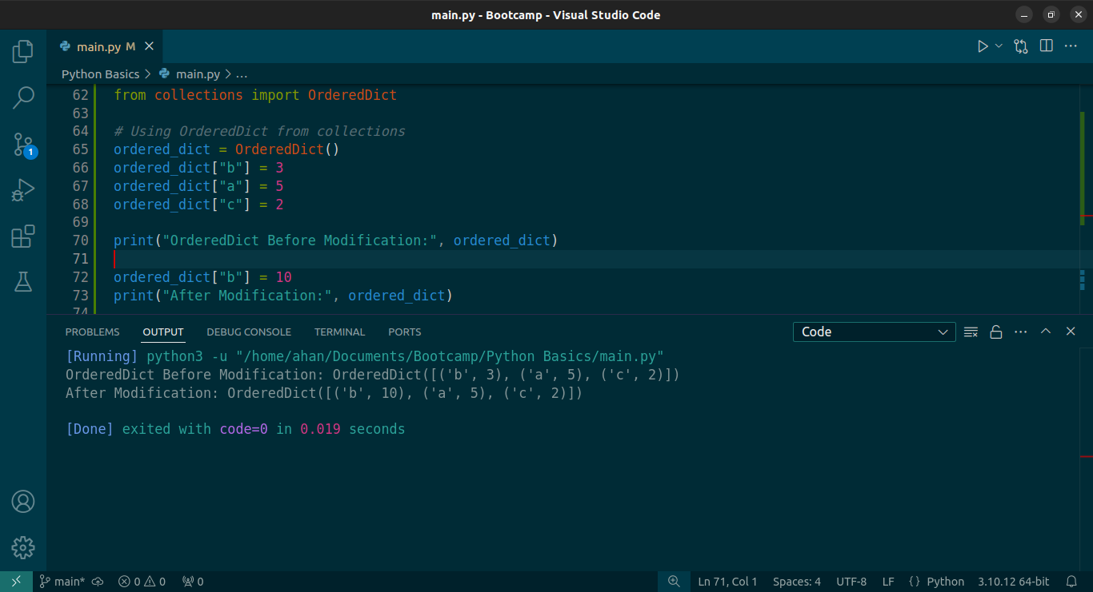

**5. Using keys and indexing, grab the 'hello' from the following dictionaries:**

d1 = {'simple_key':'hello'}

d2= {'k1':{'k2':'hello'}}

d3 = {'k1':[{'nest_key':['this is deep',['hello']]}]}

d4= {'k1':[1,2,{'k2':['this is tricky',{'tough':[1,2,['hello']]}]}]}

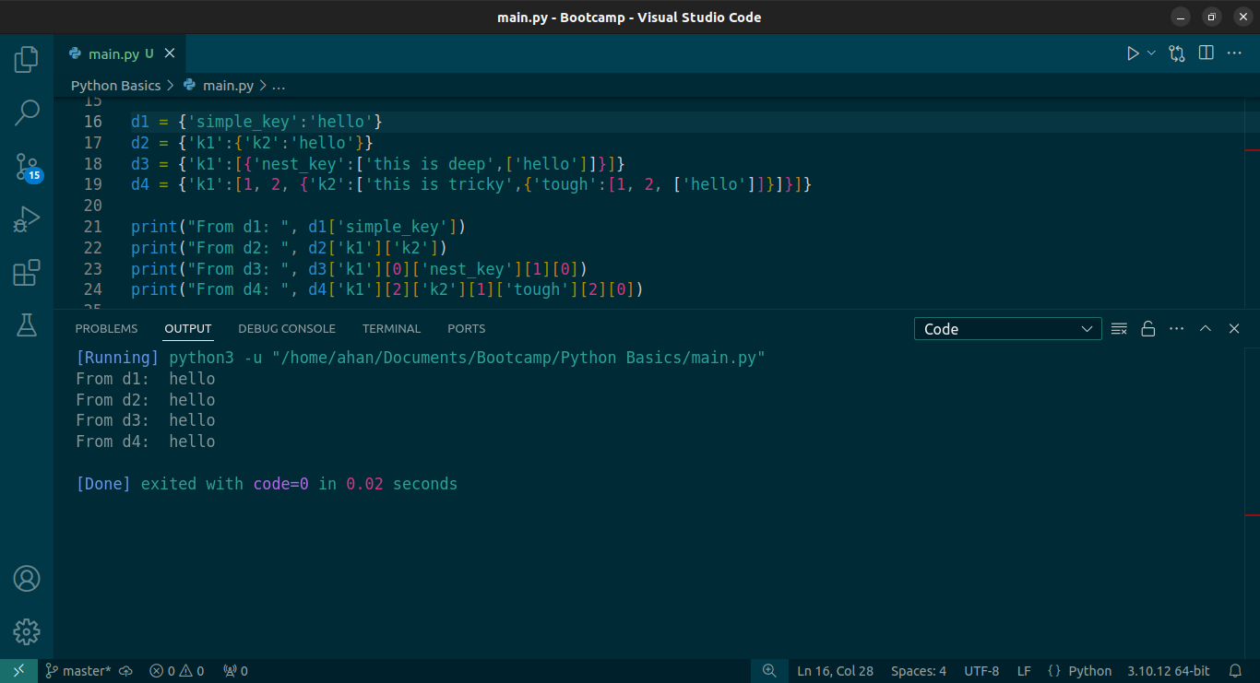

**6. Reassign 'hello' in this nested list to say 'goodbye' instead:** list3 = [1,2,[3,4,'hello']]

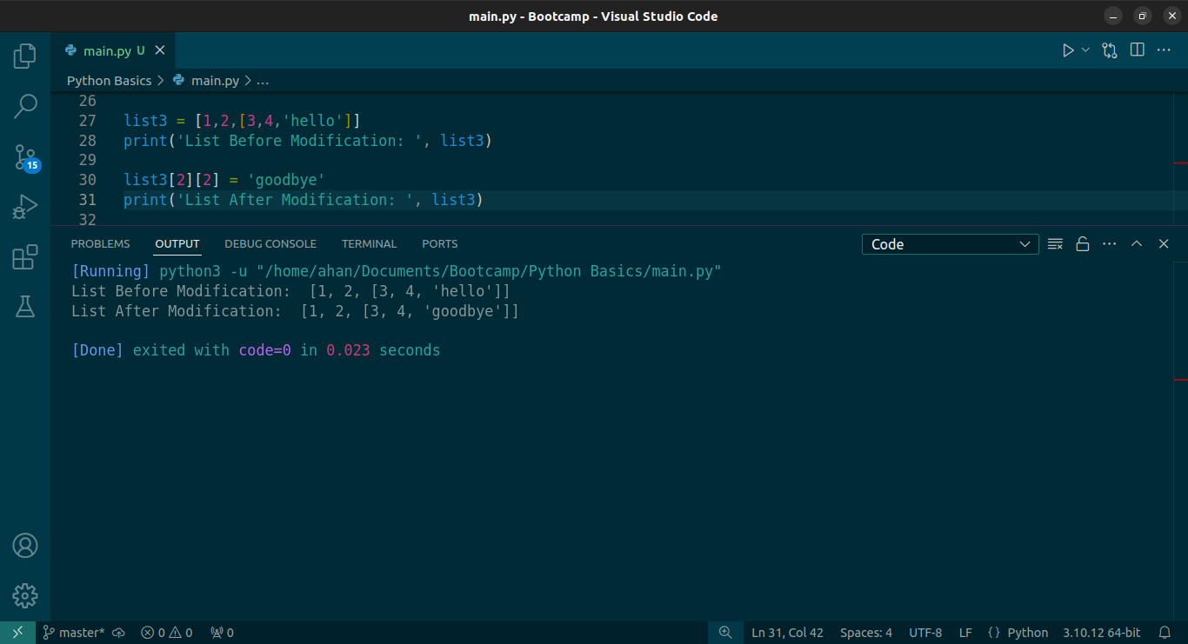

**7. From the given list list5 create a set:** list5 = [1,2,2,33,4,4,11,22,3,3,2]

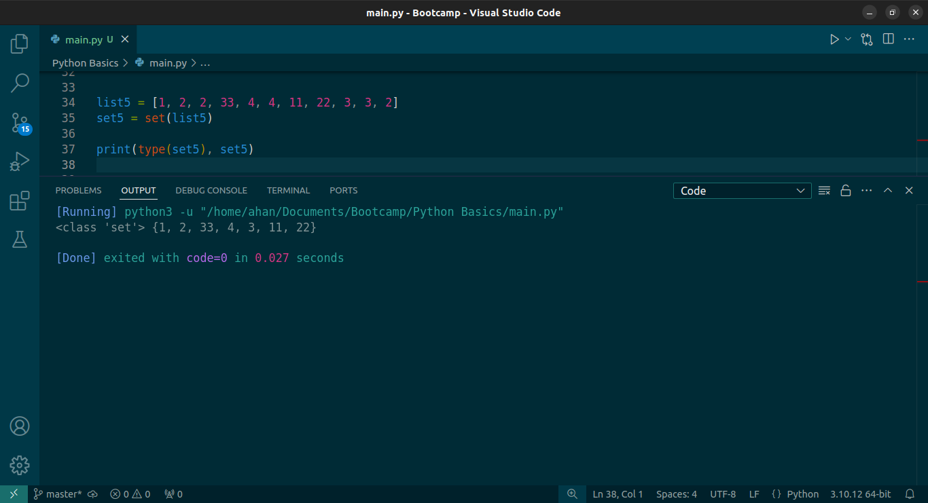

**8, In string information count the total number of i.**

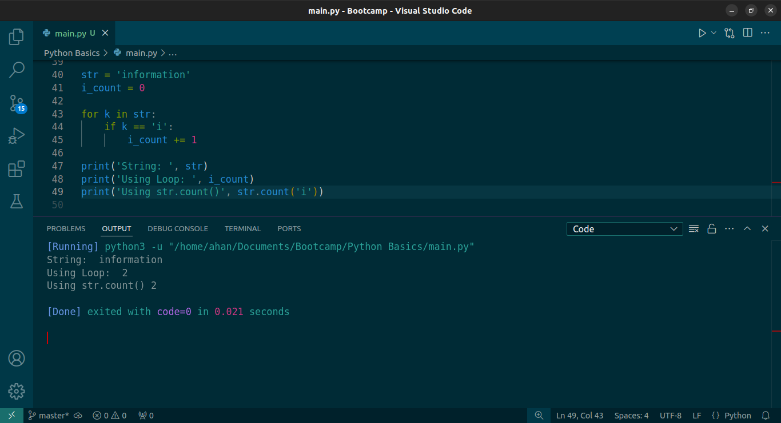

**9. Write a Python script to test if a number is prime or not? - The Script name: primes.py - Add a function is_prime() which returns boolean True or False - Program should accept a number from console.**

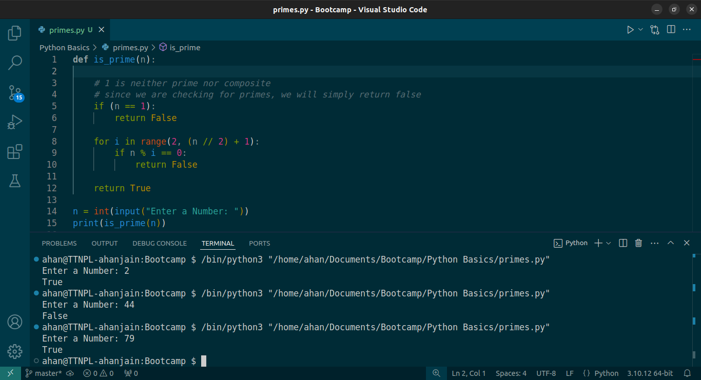

**10. Write a code to print binary, octal or hexa-decimal presentation of a number. Do not use any third party library.**

